
What we collect
We accept:
• Men’s Clothing • Women’s Clothing
• Children’s Clothing • Household textiles i.e. Curtains, Towels
- Soft Toys • Shoes • Handbags • Belts
- Laptops
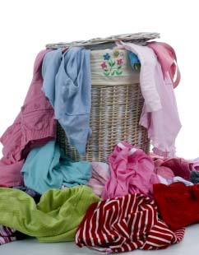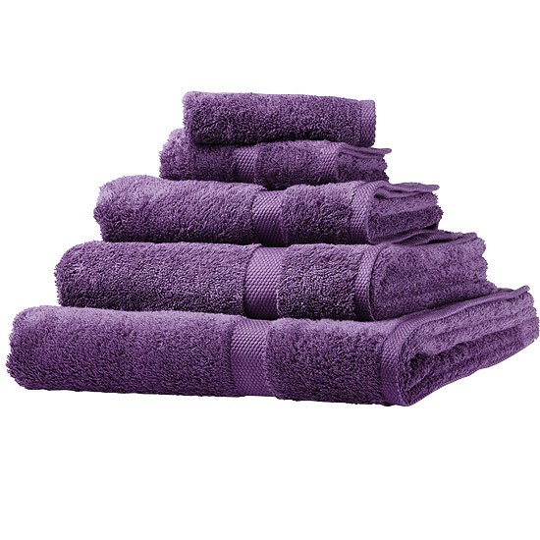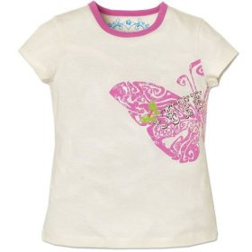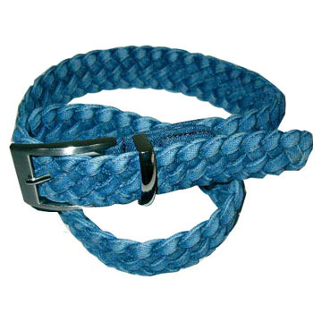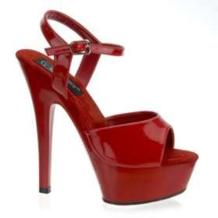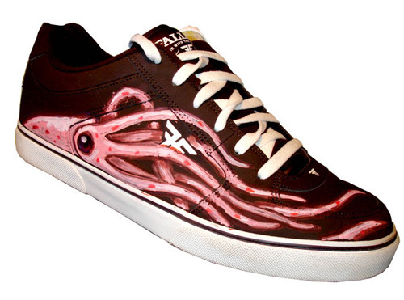
Unfortunately we cannot accept
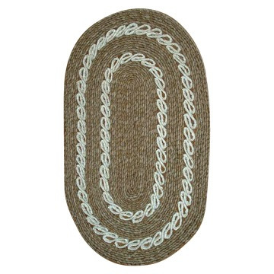
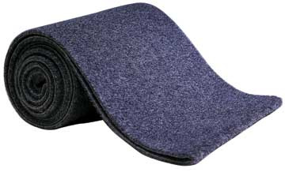
• Dirty or wet clothing
• Mats
- Carpets
- Duvets/Pillows

To organise a collection for your club or organisation please contact
ANNMARIE ON 087 992 1646 annmarie.lenrec@gmail.com or visit our website www.lenrec.ie

