Kilcleagh N. S.

INTERNET ACCEPTABLE USE POLICY
The aim of this Acceptable Use Policy is to ensure that pupils will benefit from learning opportunities offered by the schools’ internet resources in a safe and effective manner. Internet use and access is considered a school resource and the conditions of its use must be adhered to. Kilcleagh N.S. will employ a number of strategies to maximise learning opportunities and reduce risks associated with the Internet. These strategies are as follows:
- Acceptable Usage Policy
- Education
- Filtering/Monitoring
It is envisaged that the school will revise the AUP annually.
This version of AUP was created on June 5th 2013 by the staff of Kilcleagh N.S.
Introduction
The internet is a valuable teaching and learning tool. It provides information and allows people to communicate with others and share information. It can develop children’s independent research skills and promote life-long learning. However, some material available on the Internet is unsuitable for children and therefore these guidelines will be followed when using the internet.
Pupils’ use of the Internet
Pupils are responsible for good behaviour on the internet. Access to the Internet may be withdrawn from pupils who fail to maintain acceptable standards of use. Internet access in the school includes a filtering service. However no filtering service is completely foolproof and therefore pupils will be supervised during the use of the internet.
The school will employ a number of strategies in order to maximize learning opportunities and reduce risks associated with the Internet
General:
Internet will be used for educational purposes only
- Internet sessions will always be supervised by a teacher
- Teachers will ensure that pupils understand appropriate use of the internet and are aware of the rules
- Pupils will not be allowed to upload or download material without specific permission from a teacher
- Pupils and teachers will be provided with training in the area of Internet safety
- Virus protection software will be used and updated on a regular basis
- The use of personal USBs or disks in school requires a teachers permission
- Pupils will be encouraged to tell a teacher immediately if they encounter any material that makes them feel uncomfortable.
- Pupils will observe good ‘netiquette’ (etiquette on the internet) at all times and will not undertake any action that may bring a school into disrepute
- ‘YouTube’ (and similar sites) can be accessed only under the supervision and direction of the teacher.

The staff will ensure to the maximum extent possible, that pupils know and understand that no internet user is permitted to:
- Use the internet for any illegal activity including accessing other computers.
- Retrieve, send, copy or display offensive messages or pictures.
- Use obscene or offensive language.
- Cause damage to computers, computer systems or networks.
- Violate copyright laws.
- Use another user’s password.
- Trespass in another user’s folders, work or files.
- Cause any form of vandalism to the machine or the work of others including the up loading or creation of viruses.
Organisation and Management of Internet Use
Staff will select and supervise sites which will support pupils’ learning. Pupils may be given details of suitable sites to extend their learning at home as and when appropriate.
Children’s Use of Email:
- Children in school must only use email for educational purposes and e-mails will be checked by a teacher before being sent.
- Pupils will not reveal their own or other people’s details, such as names phone numbers or photographs via school email
- Pupils will not be allowed to send personal emails from the school system without permission.
- In-coming email will be regarded as public and may be examined by any staff member. The use of chat rooms is strictly forbidden.
- Pupils will never arrange to meet someone via school email.
- Sending or receiving email attachments is subject to teacher permission.
- Pupils will not send text messages
Internet Chat:
At the moment it is not envisaged that pupils will be involved in Internet chat rooms but from time to time various projects come to pass and a teacher may feel it would be educationally beneficial to the pupils to participate in such a project. For example Intercultural and Cross Border Projects have been highly successful enabling pupils to communicate with each other via Internet chat thus learning and sharing information about their worlds.
School Website:
Teachers will manage the publication of material on the school website
Pupils may create projects, artwork, writing or audio-visual recordings which would be suitable for publication on our school’s website.
- Personal pupil information, home addresses and contact details will not be published on the school website
- Class lists will not be published
- Pupils’ full names will not be published beside their photograph
- Digital photographs, video clips and audio clips will focus on groups and group activities rather than on individual pupils when possible
- Pupils will be given an opportunity to publish projects, artwork or school work on the school website
- Teachers will select work to be published and decide on the appropriateness of such
- Permission to publish a student’s work will be sought from pupils/parents/ guardians. This permission may be withdrawn at any time
8. Pupils will continue to own the copyright on any work published.

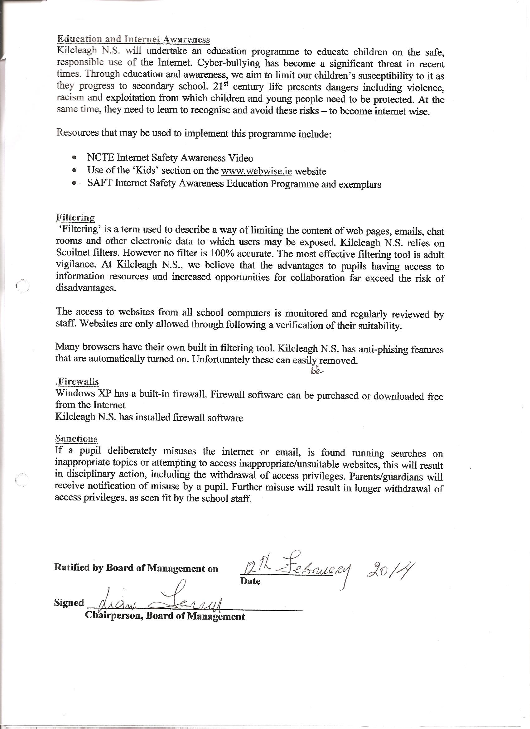

Internet Parent Permission Form
Dear Parents,
As part of the school’s ICT Programme, pupils will have supervised access to the Internet which can greatly enhance their learning experience. As you are probably aware, the Internet contains a vast amount of information but unfortunately not all of this is suitable for children and so we have produced an Acceptable Use Policy specifying our guidelines.
Before being allowed to use the Internet, all pupils must obtain parental permission. We therefore ask that both you and your child sign the enclosed form as evidence of your approval and acceptance of the school rules on this matter.

A copy of our Acceptable Use Policy available for viewing on our School Website.

Please read the AUP carefully.

Name of Pupil …………………………………………
I allow my child (Name): ……………………………… to use the Internet in school and accept school rules on this matter.
Signature of Parent …………………………………… Date……………………………
Please complete this form and return to the Principal
Pupil
I agree to comply with the school rules on the use of the Internet. I will use the Internet in a responsible way and observe all the restrictions explained to me by the school.
Pupil signature: __________________________________ Class: _____________________
Parent
As the parent or legal of the above pupil, I have read the Acceptance Use Policy and grant permission for my son/daughter to access the Internet. I understand that Internet access is designed for educational purposes. I also understand that the school cannot be held responsible if pupils access unsuitable websites, but that every reasonable precaution has been taken by the school to provide for online safety.

Parent Signature: ________________________________________ Date: ________________

Telephone No: ________________________________
School Website
I understand that, if the school deems it appropriate, my daughters/son’s school work may be chosen for inclusion on our school’s World Wide Web pages which will be published on the Internet. My daughter/son’s picture may also be published on the school website. No personal details will be given with the pupil’s pictures. The pupil continues to own the copyright on any work published. Please sign to confirm that you are aware of this:
Parent Signature: ________________________________________ Date: ________________

Responsible Internet Use - Pupil Undertaking
We use the School computers and Internet connection for learning. These rules will help us to be fair to others and keep everyone safe.
- I will ask permission before entering any website, unless my teacher has already approved that site
- I will not bring external storage devices such as pen drives (or memory sticks/USB keys etc.) into school without permission
- I will not use email for personal reasons
- I will only use email for school projects and with my teacher’s permission
- The messages I send will be polite and sensible
- When sending email, I will not give my home address or phone number or arrange to meet anyone
- I will ask for permission before opening an email or an email attachment
- I will not use internet chat rooms
- If I see anything I am unhappy with, or if I receive a message I do not like, I will tell a teacher immediately
- I know that the school may check my computer files and may monitor the sites I visit
- I understand that if I deliberately break these rules, I could be stopped from using the Internet and computers and my parents will be informed.
Signed: ______________________________________________________________(Pupils)
Signed: _______________________________________________________Parent/Guardian
Date:___________________________________
